README.MD

* Place the files : input_restriction.py

dsa.py

dsaplot.py

automate.sh , all in the same folder

* Open Terminal in the folder
* Type “chmod +x automate.sh”
* Type “bash automate.sh”
* The file will not start executing all the scripts in backend and a few files will be generated after some time
  + inputwlogs.npy
  + O(k)constant.csv
  + O(2^n)exponential.csv
  + O(n^2)quadratic.csv
  + O(n^3)cubic.csv
  + O(logn)logarithmic.csv
  + O(n)linear.csv
  + O(k)constant.png
  + O(2^n)exponential.png
  + O(n^2)quadratic.png
  + O(n^3)cubic.png
  + O(logn)logarithmic.png
  + O(n)linear.png

**To change the input size:**

* Open automate.sh in text editor
* Change the value of 27 to the value you like.

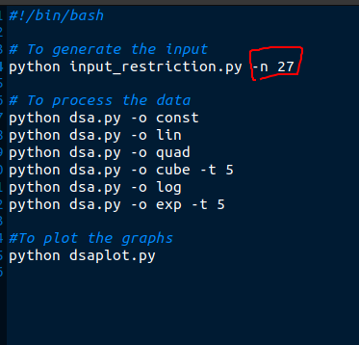

* If n==10, it means the maximum input size generated will be 2^10 = 1024
* Run the automate.sh bash script.
* Note if the program gets automatically killed.
* If yes, reduce the value of n
* Else, you may increase the value of n to test the boundary conditions.
* Ideal value of n as per the experimentation on a PC with
  + Intel i7 8th gen with Turbo Boost upto 4.5Ghz
  + 8GB RAM
  + NVIDIA Graphics card
  + 512 GB ROM is **27**